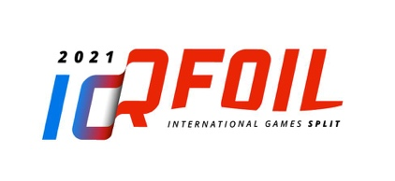

2021 iQFOiL INTERNATIONAL GAMES

May 4th - 9th 2021 – Split, CROATIA

PARENTAL PERMISSION FORM
(Only for Competitors under 18)

I,

Being the parent / legal guardian of

approve his/her entry to this event and

will be present at the event myself

OR
I hereby give permission to
to sign for any medical or surgical treatment necessary for my child during the event in Split, Croatia.

Permission is also granted for drug testing to be performed in accordance with World Sailing Anti-Doping Code. This form does not constitute therapeutic exemption of a prohibited substance. Please contact your National Sailing Federation for obtaining such exemption when necessary.

Contact details at the event for the responsible adult named above

Please complete this form, print it out
and bring to the Registration Desk at the event venue

